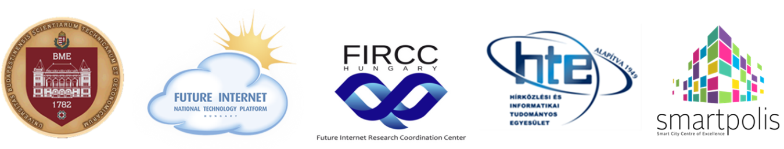

5th Hungarian Future Internet Conference
» Focusing on Smart City «

Budapest University of Technology and Economics, Central Building
November 28. 2018
Main patron: Prof. Dr. János Józsa rector, BME

The Future Internet is one of the main driving force of the innovation nowadays, and a key element of the deploying Internet Ecosystems and Networked Society all over the world. The 5th Hungarian Future Internet Conference is the national forum of the Next Generation Internet in Hungary in 2018 as the previous conferences in 2014, 2015, 2016 and 2017. The 5th conference also overviews the research trends of the Internet technologies and focuses on the Smart City issues.
The 5th Hungarian Future Internet Conference (in Hungarian: Magyar Jövő Internet Konferencia, MJIK 2018) will be held at November 28, 2018, and hosted by the main organiser Budapest University of Technology and Economics (BME) in the Central Building (1111 Budapest, Műegyetem rkp. 3.). The co-organisers of the MJIK2018 are the Scientific Association for Infocommunications (HTE), the Future Internet National Technology Platform (FI NTP), the Future Internet Research Coordination Centre (FIRCC) and the SmartPolis project. The Scientific programme is fostered by the Research Centre “Smart City ─ Smart Government” based on the cooperation of the BME and the National University of Public Service.
The languages of the event are Hungarian and English. The Conference’s morning programme is devoted to the progress of the Smart City concepts and projects, and the driving forces of the Next Generation Internet, the afternoon sessions to the presentation of the Future Internet research trends and results and the Smart City applications, engineering solutions and products.
Please register to the MJIK 2018 on www.hte.hu/mjik2018 without registration fee, from 28 September. The program of the Conference will be also shown on this site.
Looking forward to seeing you in Budapest
Budapest, 4 September 2018
Dr. Peter Bakonyi  President, FI NTP  bakonyip@eit.bme.hu | Prof. Dr. Gyula Sallai  Scientific Director, FIRCC  sallai@tmit.bme.hu

Prof. Dr. László Jakab
Dean, BME-VIK
jakab@ett.bme.hu

